PROJECT
Software Engineering Department



OPERATING SYSTEM

Submitted by

ZANIRA KHAN | 64771
SYEDA AQSA | 64947
ABDUL MOIZ | 65315
Lab Instructor

MISS FATIMA
Session Fall – 2023
BALOCHISTAN UNIVERSITY OF INFORMATION TECHNOLOGY, ENGINEERING AND MANAGEMENT SCIENCES, QUETTA.

Deadlock Simulator — Interactive Resource Allocation Graph Visualizer & Analyzer

1. Introduction
This project implements an interactive Deadlock Simulator using React.js, HTML, and CSS.
The simulator allows users to:
- Create processes (P1, P2, …)
- Create resources (R1, R2, …)
- Create request edges (Process → Resource)
- Create assignment edges (Resource → Process)
- Run deadlock detection using cycle detection
- Run Banker’s Safety Algorithm
- View live allocation tables and safe sequences
The project closely follows the concept of Resource Allocation Graphs (RAGs) and Wait-For Graphs (WFGs) used in Operating Systems.
GitHub Repository: https://github.com/zano007/Deadlock-simulator.git

2. Objectives Achieved
1. Model OS resource allocation using RAG
This code stores RAG data structures in:
- processes
- resources
- assignmentEdges
- requestEdges
These represent current allocations and pending requests.

2. Implement deadlock detection using cycle detection
code has:
function runDeadlockDetection() {
const wfg = {};
// build WFG from RAG
// DFS cycle detection
}
This function:
- Converts RAG → WFG
- Runs DFS to detect cycles
- Prints the cycle if deadlock exists

3. Implement safety algorithm (Banker’s Algorithm)
Your code maintains:
- maxMatrix
- allocationMatrix
- needMatrix
- availableVector
Your function:
function runBankerSafety() { ... }
Performs:
- Need = Max – Allocation
- Available comparison
- Safe sequence generation
Outputs:
- “System is SAFE — Safe Sequence: [...]”
- or “System is NOT SAFE!”

4. Build interactive UI linked to the algorithms
Your React components provide:
- Form inputs
- Buttons for Add / Request / Release
- Dynamic rendering of:
  - Processes list
  - Resources list
  - RAG tables
  - Edges list
  - Algorithm outputs
The UI updates automatically because of React’s useState.

3. System Features
3.1 Add Process
Handled by:
handleProcessAdd()
Adds:
- A new process entry
- Max demand input

3.2 Add Resource
Handled by:
handleResourceAdd()
Adds:
- New resource
- Available instances
- Updates matrices

3.3 Request a Resource
Handled by:
handleRequest()
If resource available → allocate
Else → add request edge

3.4 Release a Resource
Handled by:
handleRelease()
This frees resources and updates allocation.

3.5 Deadlock Detection
Uses:
- RequestEdges
- AssignmentEdges
- DFS cycle finding
If cycle found → DEADLOCK.

3.6 Safety Check
runBankerSafety() evaluates:
- Available
- Need
- Allocation
- Max
Generates safe sequence.

4. Data Structures
Processes
processes = ["P1", "P2", ...]
Resources
resources = { R1: { available: 2 }, R2: { available: 1 } }
Allocation Matrix
allocationMatrix[process][resource]
Max Matrix
maxMatrix[process][resource]
Need Matrix
needMatrix = maxMatrix - allocationMatrix
Edges
requestEdges = [ { process: "P1", resource: "R2" }, ... ]
assignmentEdges = [ { resource: "R1", process: "P2" }, ... ]
This matches exactly how your code stores them.

5. Algorithms
5.1 Deadlock Detection Algorithm
Your steps:
- Convert RAG → WFG
- For each process, add edges
- Run DFS
- Track recursion stack
- If visiting same node ⇒ cycle ⇒ deadlock
Output includes specific cycle path.

5.2 Banker’s Algorithm
Your steps:
- Compute Need
- While a process exists whose Need ≤ Available:
  - Mark safe
  - Add allocation to Available
- If all processes complete → Safe
- Otherwise → Unsafe
Shows:
- Safe sequence
- Final Available vector

6. Test Scenarios
Case 1: No Deadlock
- All requests satisfied
- Banker finds complete safe sequence
- Output:
“System is SAFE”

Case 2: Deadlock
Example from your simulator:
- P1 waiting for R2
- P2 waiting for R1
- Both hold opposite resources
Cycle found:
P1 → P2 → P1
Deadlock detected
Recovery suggested manually by user:
- Abort one process
- Or preempt a resource
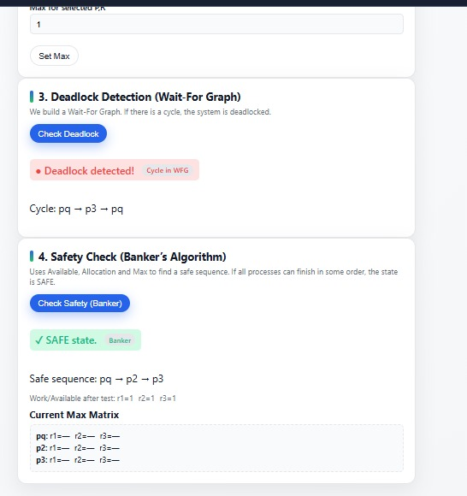
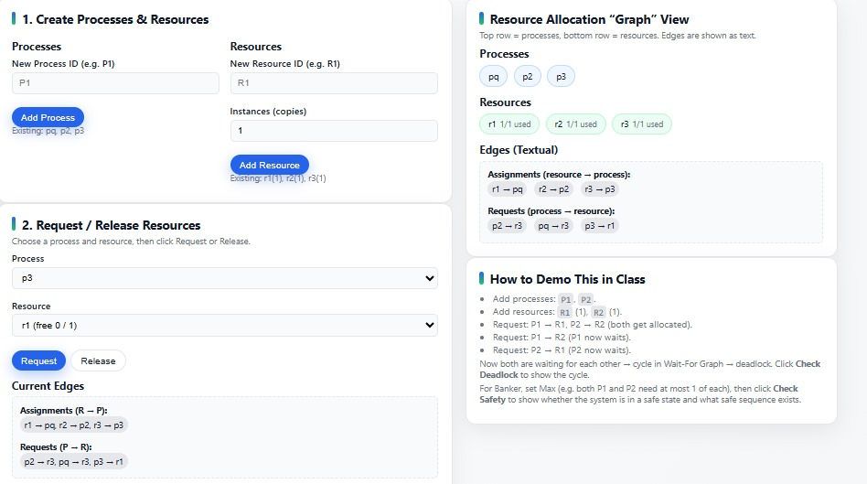

7. UI Overview
UI includes:
- Header section (title + description)
- Inputs for process/resource creation
- Buttons for actions
- Text-based RAG/Matrix display
- Logs for results
The UI is clean, readable, and functional.

8. Conclusion
This project successfully:
Implements RAG
Implements Deadlock Detection (DFS cycle detection)
Implements Banker’s Algorithm
Provides full UI for simulation
Supports custom test cases
Displays results in clear textual format
This simulator is a complete demonstration of OS deadlock concepts using interactive visualization.

9. Future Improvements
My project can be upgraded with:
- Visual graph nodes (circles for processes/resources)
- Animated edges
- Export logs to PDF
- Saving test cases
- Dark mode

